Transformation in ETL
Question no 1:
Define Data Transformation in ETL and explain why it is important.
Answer:
Data transformation in ETL is the critical middle phase that cleans, conforms, and restructures raw data from various sources into a standardized, analysis-ready format. It involves applying business rules to convert data types, filter, aggregate, and validate information, ensuring consistency and accuracy before it is loaded into a data warehouse.
Why Data Transformation is Important:
- Ensures Data Quality: Removes duplicates, handles null values, and cleans errors to provide trustworthy, high-quality data.
- Enables Data Consistency: Standardizes formats, units, and structures across disparate sources, making it easier to integrate and analyze.
- Improves Performance: Pre-processes, aggregates, and filters data, reducing storage needs and increasing query speed for faster reporting.
- Supports Data-Driven Decision-Making: Transforms raw data into a usable, organized format ready for BI tools and advanced analytics.
Key transformation operations include filtering, joining, splitting, formatting, and aggregating data.

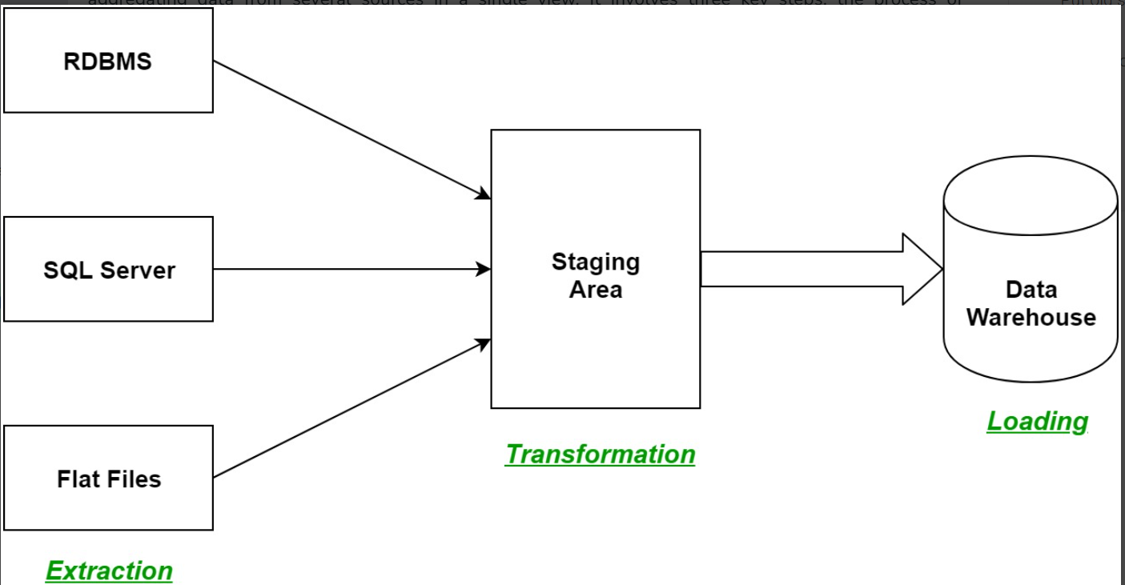

Question no 2:
List any four common activities involved in Data Cleaning.
Answer:
Data cleaning is the process of preparing raw data by detecting and correcting errors so it can be effectively used for analysis. It is a foundational step in data preprocessing that ensures datasets are suitable for analytical, statistical and machine learning tasks.
- Eliminates duplicates, missing values and inconsistencies that can distort analysis
- Enables organizations to make decisions based on accurate and up to date information
- Reduces effort and time spent handling errors during data analysis and reporting
- Strengthens the reliability of analytics, AI and machine learning outcomes
- Supports adherence to data quality standards and regulatory requirements.
Data cleaning involves several essential activities to ensure data quality, accuracy, and usability. Four common activities include:
- Handling Missing Data: Addressing incomplete data by either removing records (rows) with missing values, or filling them in using techniques like imputation (replacing with mean, median, or mode).
- Removing Duplicates: Identifying and eliminating redundant, identical, or nearly identical records to avoid inflating metrics and wasting storage.
- Standardizing Formats: Ensuring consistency across the dataset, such as converting all date formats to "YYYY-MM-DD" or standardizing text case (e.g., converting "USA" and "u.s.a." to "United States").
- Fixing Structural Errors: Correcting typographical errors, mislabeled categories, or inconsistent naming conventions (e.g., standardizing "California" and "CA" to "CA").
Question no 3:
What is the difference between Normalization and Standardization?
Answer:
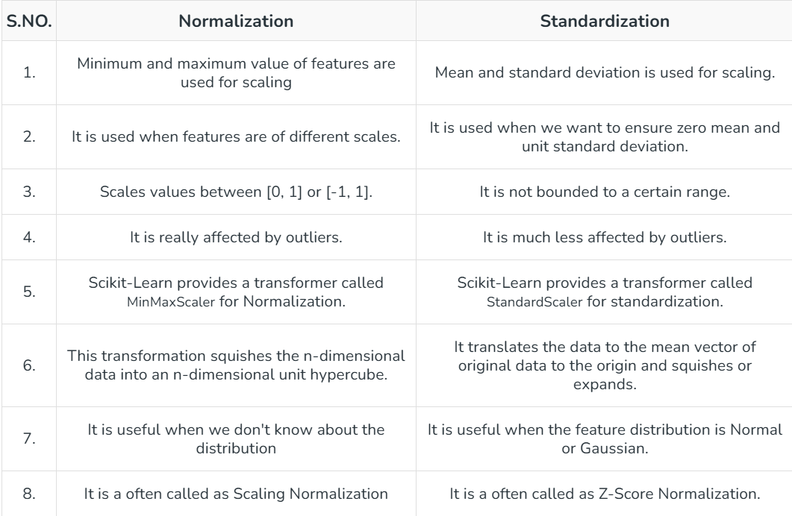
Question no 4:
A dataset has missing values in the “Age” column. Suggest two techniques to handle this and explain when they should be used.
Answer:
Handling missing "Age" values can be done via imputation (replacing with median/mean) or deletion (dropping rows). Use median imputation when data is skewed or has outliers to prevent bias. Use listwise deletion (dropping rows) only if the missing data is minimal (e.g., <5%) or completely at random, avoiding significant information loss.
Imputation (Median or Mean)
- What it is: Replacing missing "Age" values with the calculated median or mean age of the dataset (or a subset, like a specific gender/job title).
- When to use: Use median if the age distribution is skewed or has significant outliers. Use mean if the data is normally distributed. It is best when you have a small dataset and cannot afford to lose data points.
Deletion (Listwise Deletion)
- What it is: Removing the entire row (record) that contains a missing "Age" value.
- When to use: Use this method when the number of missing values is very small (negligible) compared to the total dataset size, or if the missingness is completely random. Note: This can lead to significant information loss if overused.

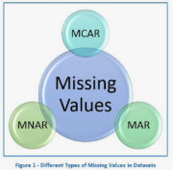
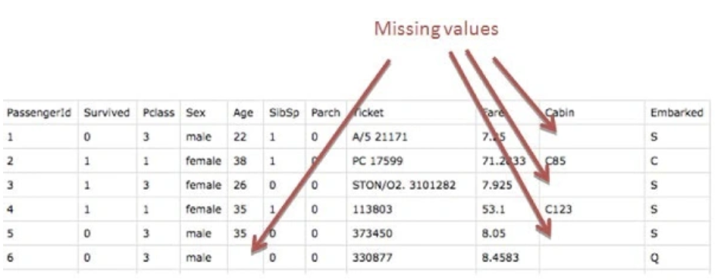

Question no 5:
Convert the following inconsistent “Gender” entries into a standardized format (“Male”, “Female”): ["M", "male", "F", "Female", "MALE", "f"]
Answer:
To standardize the inconsistent gender entries ("M", "male", "F", "Female", "MALE", "f") in an ETL transformation process, you should implement a mapping logic that converts all variations to a uniform, clean format ("Male" or "Female").
Here are the standard approaches used in ETL processes:
1. Mapping Strategy
Male: "M", "male", "MALE", "m" -> Male
Female: "F", "Female", "f", "FEMALE" -> Female
2.Transformation Examples
Depending on the tool, the logic is implemented as follows:
Python (Pandas):
df['Gender'] = df['Gender'].str.strip().str.upper() # Standardize case and remove whitespaces
df['Gender'] = df['Gender'].replace({'M': 'Male', 'MALE': 'Male', 'F': 'Female', 'FEMALE': 'Female'})
SQL (Case Statement):
SELECT
CASE
WHEN UPPER(TRIM(Gender)) IN ('M', 'MALE') THEN 'Male'
WHEN UPPER(TRIM(Gender)) IN ('F', 'FEMALE') THEN 'Female'
ELSE 'Unknown' -- Optional handling for other values
END AS Gender
FROM TableName;
ETL Tool (e.g., Talend/Informatica):
  - Create a "Replace" or "Lookup" mapping (Map "M" -> Male, "F" ->Female).
  - Use an UPPER() transformation to handle case inconsistencies before mapping.
3. Key Considerations
- Case Sensitivity: Convert all input data to uppercase (or lowercase) before replacing to ensure all variants (e.g., "m" and "M") are caught.
- Whitespace: Trim leading/trailing spaces (e.g., "M " ->"M") to prevent mapping failures.
- Unknown Values: Use an ELSE condition to map unexpected values to "Other" or NULL rather than failing the job

Question no 6:
What is One-Hot Encoding? Give an example with the categories: “Red, Blue, Green”.
Answer:
One-hot encoding is a preprocessing technique in machine learning that converts categorical data into a numerical binary vector representation. It creates new binary columns for each unique category, marking the presence of a category with a 1 ("hot") and others with 0s ("cold"). This prevents models from assuming ordered relationships.
Example: Red, Blue, Green
For the categories "Red", "Blue", and "Green", one-hot encoding transforms them into 3D binary vectors:
Category | Red | Blue | Green
Red | 1 | 0 | 0
Blue | 0 | 1 | 0
Green | 0 | 0 | 1
- Red is represented as [1,0,0]
- Blue is represented as [0,1,0]
- Green is represented as [0,0,1]
Key Aspects
- Vector Length: The length of the vector equals the number of unique categories.
- Purpose: It allows algorithms to process non-numerical data without creating artificial ordinal relationships (unlike label encoding).
- Application: Commonly used when the categorical data is nominal (no specific order).

Question no 7:
Explain the difference between Data Integration and Data Mapping in ETL.
Answer:
Data integration is the broad process of combining data from various sources into a unified system,
while data mapping is a specific, foundational step within that process (and within ETL) that defines how individual data fields correspond between the source and target systems.
Defination:
Data integration is a comprehensive strategy for consolidating data from different locations and formats to provide a complete, accurate, and unified view for analysis, reporting, and business processes.
While Data mapping is the crucial, initial process of defining the relationships between specific data elements (fields) in the source system(s) and their corresponding fields in the target system.
Scope:
Broad, encompassing various methodologies beyond just ETL, such as data synchronization, application integration (API-based), data replication, and data virtualization.
While Specific to defining the "how-to" of data movement and transformation at the field level. It is a key component during the transform and load phases of an ETL pipeline.
Purpose:
To break down data silos, enhance data accessibility, and support real-time operations and decision-making across the organization.
While To ensure data accuracy and consistency during transfer by aligning different data structures, formats, and terminologies.
Process:
It involves a series of steps, including identifying data sources, extraction, mapping, validation, transformation, loading, and ongoing synchronization and governance.
While It involves creating a mapping schema or instruction set that specifies rules for data type conversions, renaming criteria, aggregation, and other transformation logic.
Role in ETL:
ETL is one specific approach to data integration.
While Data mapping is a core component within the "Transform" and "Load" stages of ETL.

Question no 8:
Explain why Z-score Standardization is preferred over Min-Max Scaling when outliers exist.
Answer:
Z-score standardization (also known as standard scaling) is preferred over Min-Max scaling when outliers exist because it is less sensitive to extreme values, ensuring that the majority of the data remains well-scaled rather than being crushed into a tiny range.
Here is a detailed breakdown of why Z-score is superior in the presence of outliers:
